Trippin’

By:
- Ofri Akerman
- Yaron Zandberg
- Tohar Harush
- Adar Ben-Lulu
- Amit Sabag
- Aml Eisami

Supervisor:
Omri Bitan

Git:
https://github.com/toharush/trippin

Table of Contents
1. Project description 3
2. Related Work 4
3. Functional Description / Requirements 5
4. Architecture 6
4.1. Each Module description 6
5. Work plan 7
6. Client side 7
6.1. Usage Illustration 7
6.2. Mockup 8
7. Server Side 12
7.1. API 12
8. References 12

Project description

The Trippin’ app helps users to calculate and create the most affective and fitted route for their vacation.
The users are asked to provide their personal preferences such as: destination, total duration of stay, places of interests in the selected destination, categories of interest and scale of interest, how many hours a day does the traveler wants to spend out and so on.
The algorithm will calculate the best route for the user by taking the data inserted and combining it with more metadata such as: location of activities, opening hours, average time spent for each activity, rate and so on.
The route will be divided into days and will be presented to the user with a smart plan for their trip – when and where to go and how long they should stay.
Trippin’ will be available both as a website and a smartphone app.
Users will be able to log in and save the suggested route, edit and change it over time.
This app is mostly useful for a first time around a new city – wanting to explore a place full of opportunities, not knowing exactly where to start but knowing the basics of what you’re looking for in your trip.
The most important part of the app is the possibility to insert your own wanted activities and attractions, along side rating the suggested options for the maximum fit.

Related Work

While exploring the suggested solutions in the market, we came across 2 significant apps:
Shichor and Google Travel. Both doesn’t meet our demands.

Shichor –
This app asks the user for the following data: destination, duration of vacation, vacation cost rate (choosing from 4 levels), number of travelers and their relation type, rating the suggested activities categories. After inserting the data, the app presents a list of recommended activities and places to visit as well as showing the places on a map.
Benefits:
- Minimum time and effort of the user for constructing the trip’s route.
- Consideration of different kind of parameters (money, traveling group and subjects of interests)
- Showing the attractions on the map.
Disadvantages:
- No specific preferences of the user are available. The user can’t insert any specific activity or place of interest, which means no direct way of influencing the route is available. This is a very important feature.
- This app selects activities the user show interest in. For example – inserting too many historical monuments even though the user didn’t ask for that category.
- No option to edit the suggested route once it has been calculated by the app. The only way to influence the route is the change the initialized data.
Overall, Schichor app is a very easy to use platform but not personal enough.

Google Travel –
This app asks the user for all the data of the trip. First, after inserting the destination and duration of the trip, an empty traveling journal is created. Then, the user can manually insert their activities for every hour of each day. As you can understand, this app only holds the details of the trip and doesn’t help planning it.
Benefits:
- Very personally fitted. No unwanted activities will be included in the trip.
- The traveling journal can automatically synchronize with Google Calendar.
- Every activity has a link to Google Maps in order to start navigation.
Disadvantages:
- Manual and time-consuming work.
- The user is required to plan the trip by themselves, thinking of every detail.
- The app only holds the data and doesn’t help with suggestions or dividing the activities to separated days or hours.
In conclusion, Google Travel takes too much time and doesn’t provide our users with any added value other than storing their data.

To summarize – the apps found across the internet don’t attend to the users needs.
Therefore, Trippin’ will provide the users with a new solution that will suggest activities and calculate the route for each day, similar to Shichor, but also provide the user with the option to insert data by themselves and edit the routes, the same as in Google Travel.

Functional Description / Requirements
- Vacation settings – entering the traveled city name, vacation days duration and the hotel/staying place
- Selecting preferred activities and vacation style –
  - showing the user a few options of popular activities in the chosen city (museums, touristic monuments, shopping, shows and concerts...) -
the user will need to enter his preference for those activities – none, a little of, a lot of
  - style of the vacation (how many hours of traveling a day, 18+, going out at night/staying in...)
- Receiving an input from the user on his own wanted activities, restaurants etc.
- Calculating a smart route – creating a route around the city, considering all user inputs, activities opening hours, average time of stay for each activity and the distance between them.
- Showing the route across the city map and a list of activities for each vacation day. The user will be able to edit the lists.
- Optional:
  - Saving the trip’s route and recommendations
  - Registration – creating a new user with email, password, first and last name
  - Login using the email and password entered at registration stage

Architecture
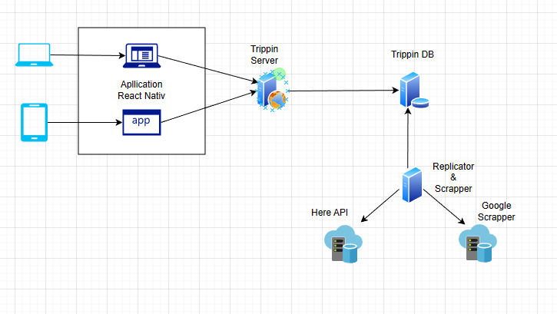

Each Module description
- Application React Native – Client side
Website and a smartphone app
- Trippin Server
Calculating the routes and communicating with the DB.
- Trippin DB
Saving users registration info, routes, preferences – received from client side.
Saving places and activities and all of the information about them – received from the replicator.
- Replicator
A server that will scrape locations and activities off Here API and Google Scraper in order to save those locally to the DB.
This architecture will prevent overload caused by too many requests to remote API’s and or big replays.
- Here API
A free API of activities, holding information such as: activity category (restaurant/museum/shop/bar…) address, locations on map, opening hours, contacts etc…
- Google Scraper
A service that holds activities info such as: average time of stay, rate, busy hours…

Work plan
- Epic – DB Design
  - Define all DB models, meaning define all relevant tables and table fields.
- Epic – Replicators
  - Write down all API calls responsible for data replication of replicator service
  - Implement replication
  - Implement saving data to the DB
  - Write down all API calls responsible for data replication of scrapper service
  - Implement replication
  - Implement saving data to the DB
- Epic – Enable boundary for fetching activities’ location to be in one country
- Epic - Create an aggregator service
  - Implement an aggregator service responsible for get all data from the replicators and create one entity that will be saved to the DB
- Epic – Server side
  - Implement authentication
  - Calculating route according parameters
  - Save route to the DB
  - Fetch data from the DB
  - Suggest trip categories according destination country
- Epic – Client side
  - Define all relevant components
  - Implement all screens
- Epic – Mobile app
  - Execute all configurations and conventions in order to be able to run the application on mobile phone

Client side

Usage Illustration

- User can sign up to the website
- User can login to the website
- The user has to choose his destination and travel duration (days and hours range)
- The user has to choose specific activities he is interested in
- The user can rate some suggested categories of activities types
- After watching the current suggested daily route, the user can adjust the route according to his wishes.
- The user can save his daily route.
- The user can access all of his saved planned routes, choose one of them, and edit the route.
- The user can delete a saved route.

Mockup
Home page no login
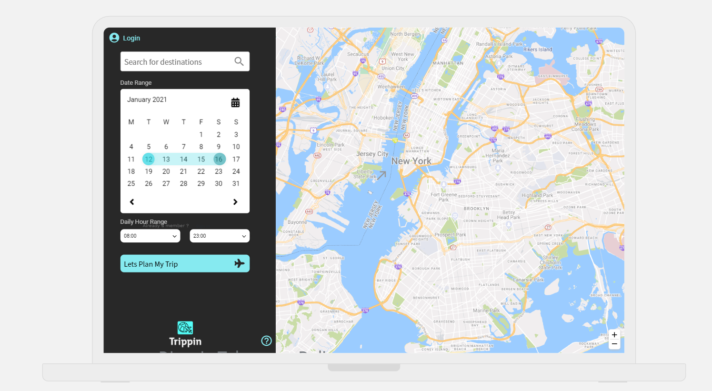

Home page login
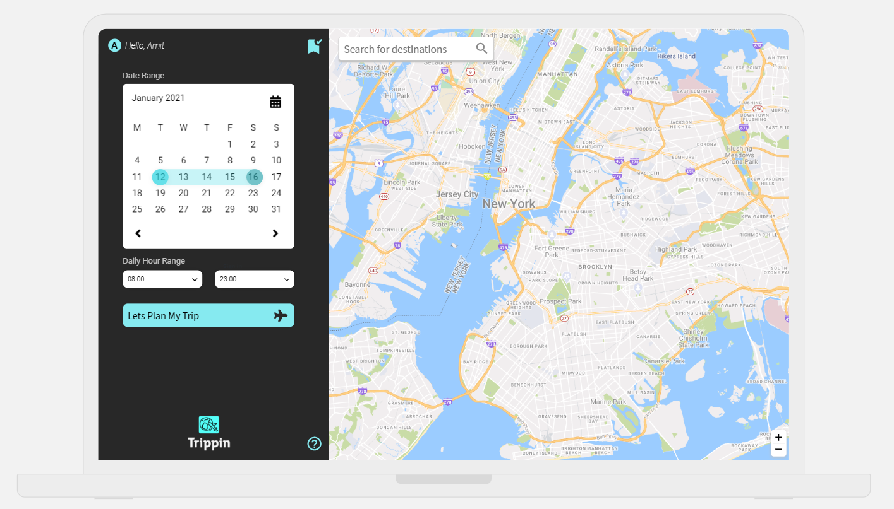

Search with categories

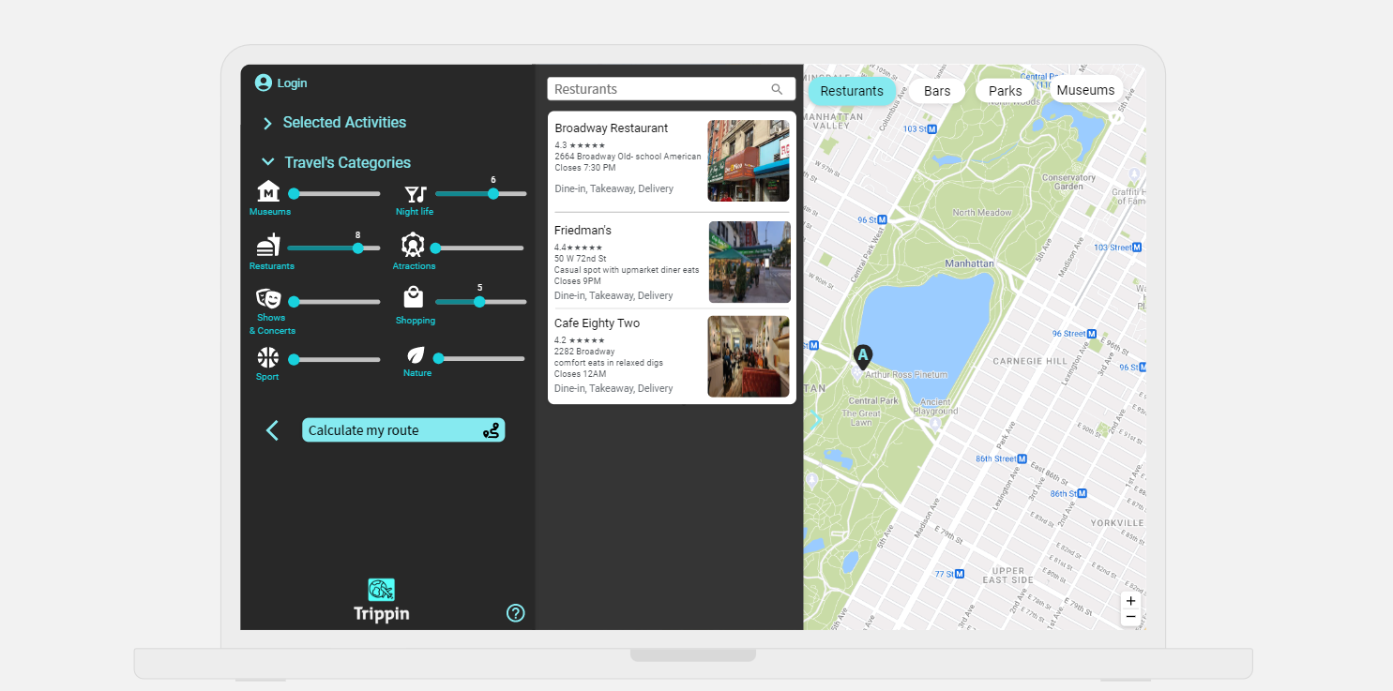
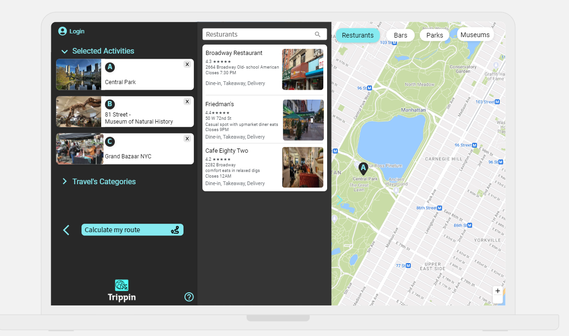

Search with selected activity

View calculated route for each day
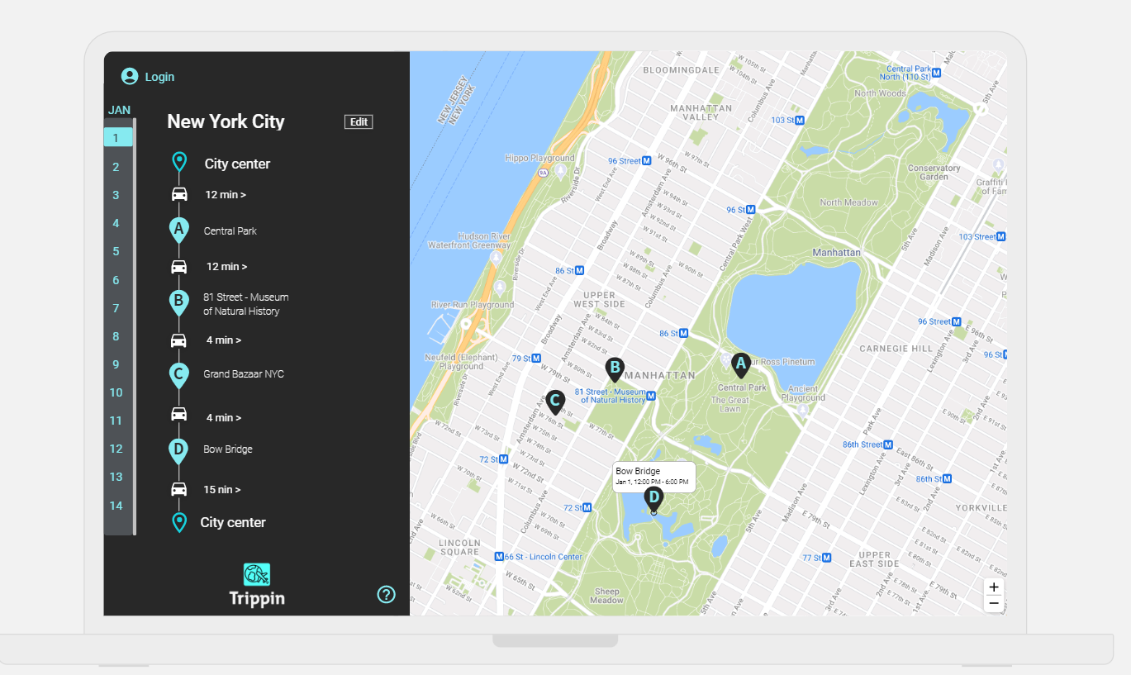

Login page

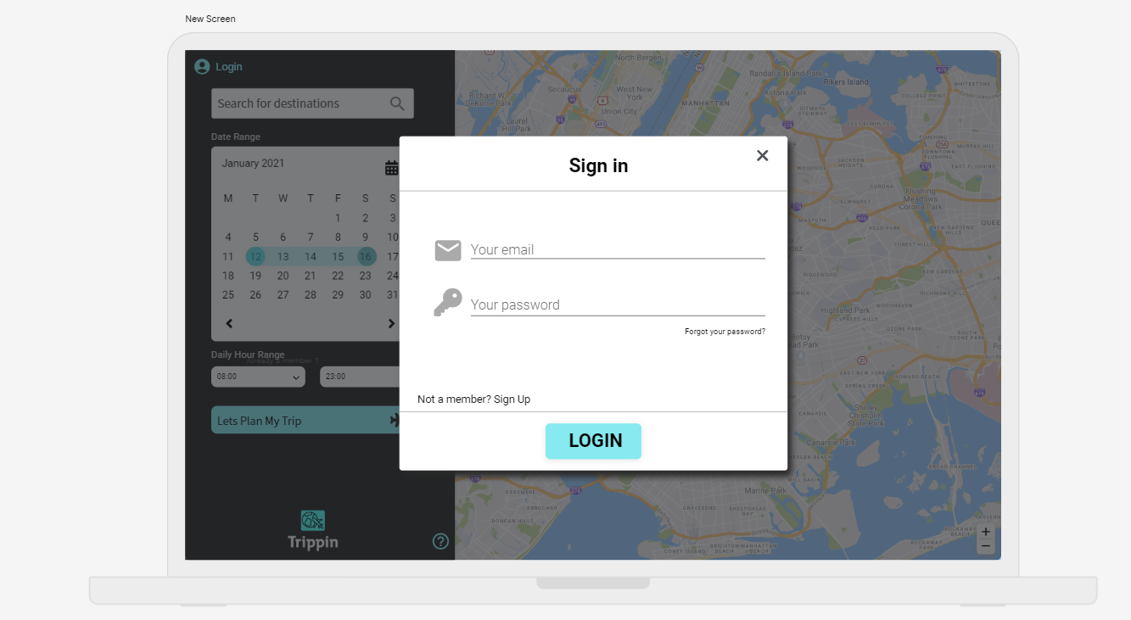
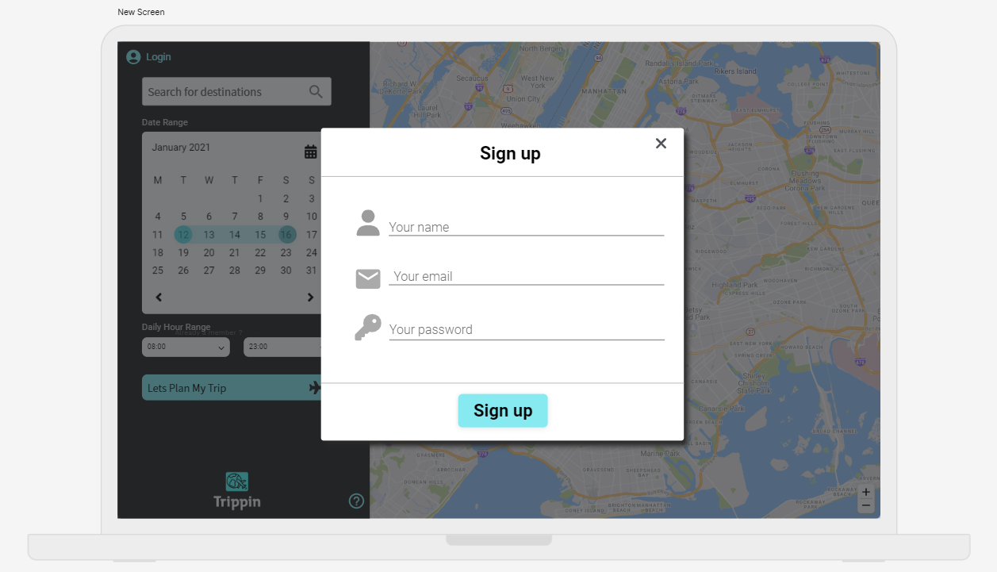
Sign up page

My planned trips page



Server Side
Calculating the route will considerate the following factors:
- Number of days for the vacation and how many hours a day to travel
- Preferred categories selected by the user
- Entered activities
- Average time of stay
- Opening hours
- Distance between activities
- Rating

API
api/v1/graphql

References
- Here API - https://developer.here.com/
- Mockup - https://app.uizard.io/p/ceb8572e
- Cesium - https://cesium.com/platform/cesiumjs/

